Introducing the “Swallow”
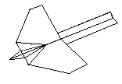

- Cut the tail out (see label on DIG. 1) and fold along the diagonal line creasing well.
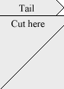 DIG. 1
- Now fold along the diagonal line on DIG. 2 creasing well.
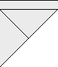 DIG. 2
- Now it should look like DIG. 3.
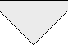 DIG. 3
- Fold along the horizontal line on DIG. 4.
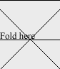 DIG. 4
- Now push this form together to make the shape in DIG. 5.
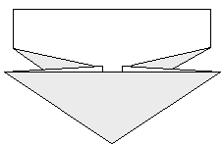 DIG. 5
- Fold the flaps over to form DIG. 6.
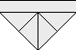 DIG. 6
- Now fold along the dark grey lines in DIG. 7.
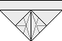 DIG. 7
- Now fold it together as in DIG. 8. Place the tail so that the angle at the end is pressed right up into the nose.
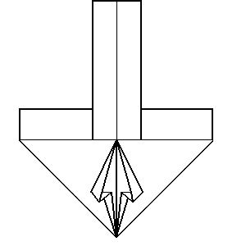 DIG. 8
- Now fold where the dotted line is in DIG. 9 under the wing trapping the tail in place.
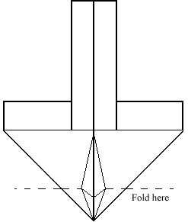 DIG. 9
- Now turn the plane over to give you the plane as shown at the top of the page.
Until next time,
Dom.

